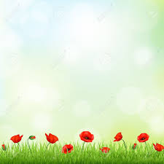

* ***In Flanders fields***

In Flanders fields the poppies blow  
Between the crosses, row on row,  
That mark our place: and in the sky  
The larks, still bravely singing, fly  
Scarce heard amid the guns below.

We are the Dead. Short days ago  
We lived, felt dawn, saw sunset glow,  
Loved and were loved, and now we lie  
In Flanders fields.

Take up our quarrel with the foe:  
To you from failing hands we throw  
The torch; be yours to hold it high.  
If ye break faith with us who die  
We shall not sleep, though poppies grow  
In Flanders fields.

*John McCrae (1872–1918)*

During the First World War, red poppies were among the first plants to spring up in the devastated battlefields of northern France and Belgium. In soldiers' folklore, the vivid red of the poppy came from the blood of their comrades soaking the ground. The sight of poppies on the battlefield at Ypres in 1915 moved Lieutenant Colonel John McCrae to write the poem In Flanders fields.